*Highlighted part is either note to internal team or content that needs to be replaced with correct values e.g. email addresses, dates, etc.*

Below is a complete Breach Response Policy for SproutSong / SproutMentors, prepared for internal team use, school-facing governance, DPDP compliance tracking, and later publication as a summary on the website.

It covers:

Internal incident response
External breach notification
Student/child data breach handling
School/institution communication
Parent/user notification
Reporting timelines
Technical containment steps
Evidence preservation
Post-incident improvement
Incident register schema
Templates

---

SproutSong / SproutMentors

Breach Response Policy

Internal + External Incident Response Plan

Document Name: Breach Response Policy
Platform: SproutSong / SproutMentors
Version: v1.0 Draft
Prepared For: Internal Security Team, Compliance Team, School Operations, Engineering, Management
Status: Draft — Legal Review Pending
Effective Date: To be added
Last Updated: To be added
Security Contact: security@sproutsong.com
Privacy Contact: privacy@sproutsong.com
Support Contact: support@sproutsong.com

---

Internal Review Checklist

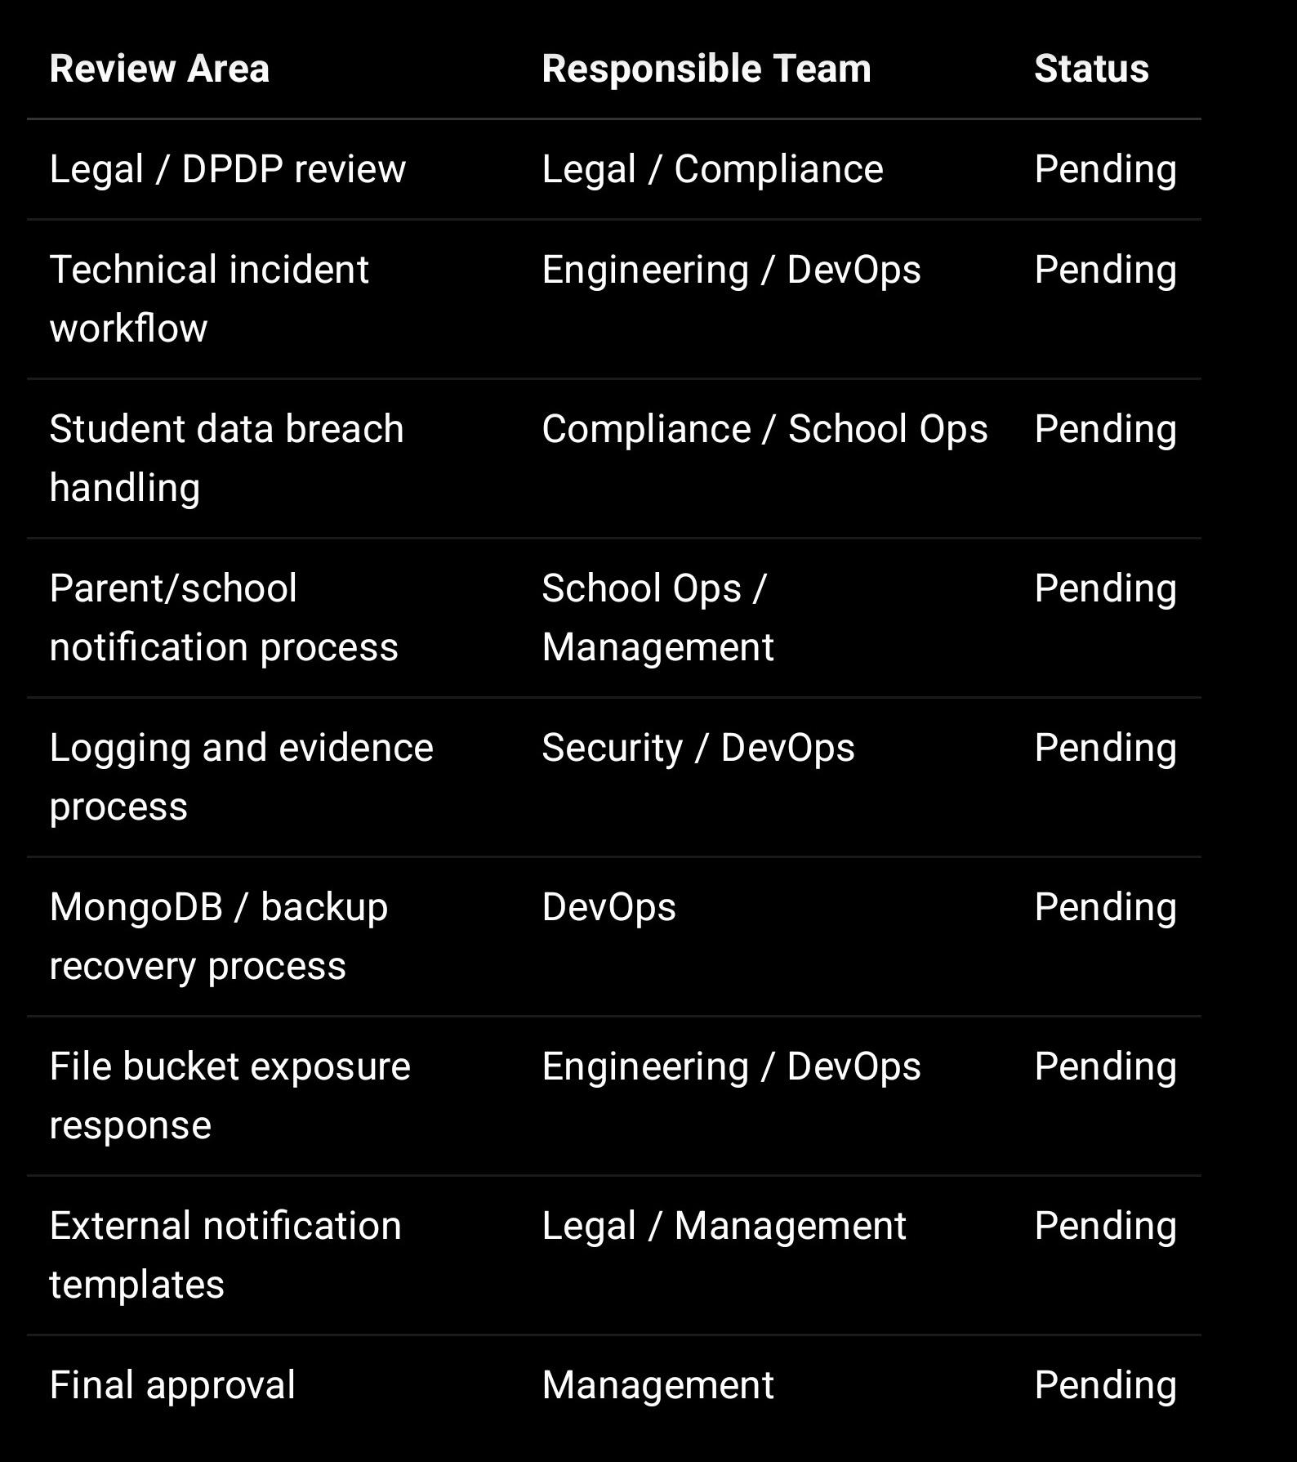

---

1. Purpose

This policy defines how SproutSong / SproutMentors will identify, contain, investigate, report, notify, fix, and document security incidents and personal data breaches.

The platform handles sensitive education-related data such as student identity data, parent/guardian data, academic records, counselling data, attendance/behaviour data, documents, login/security data, and platform analytics. The internal cybersecurity guide already recognises that protecting this data is a legal, ethical, and trust-building responsibility for an EdTech platform.

This policy applies to incidents such as:

Student data exposed to the wrong user
Wrong user logged into another user’s profile
Parent accessed another child’s report
Teacher accessed another school’s student data
Database leak
MongoDB exposed publicly
File bucket made public
Student marksheets/documents leaked
Admin account compromised
Plain passwords/tokens/OTP exposed
Sensitive data logged accidentally
AI report shown before review
Email/report sent to wrong recipient
Malware uploaded through document upload
Unauthorised bulk export
Third-party processor breach

---

2. Core Breach Response Principle

Protect the student first.
Stop the exposure quickly.
Preserve evidence safely.
Notify the right people.
Fix the root cause.
Prevent recurrence.

The teamship guide already recommends this security mindset: collect only what is necessary, give access only to the right person, keep evidence of consent, and make sure every sensitive action is secure, logged, and explainable.

---

3. Definitions

3.1 Security Incident

A security incident is any event that may affect confidentiality, integrity, availability, or authorised use of SproutSong systems or data.

Examples:

Failed access attacks
Brute-force login attempts
Malware upload attempt
API abuse
Suspicious admin login
Unusual bulk export
Repeated 403/401 access attempts
Unpatched vulnerability found

3.2 Personal Data Breach

A personal data breach is an incident where personal data is accidentally or unlawfully accessed, disclosed, altered, lost, destroyed, leaked, downloaded, shared, exposed, or made unavailable.

Examples:

Student report viewed by wrong parent
Teacher accesses another school’s students
Database leaked
Student marksheet public URL exposed
Logs contain student PII
Email sent to wrong recipient
Backup leaked

3.3 Critical Child Data Breach

A breach involving children’s/student data is treated as high priority because SproutSong handles educational journeys, parent trust, school operations, counselling data, and sensitive academic records. The internal guide notes that children’s data requires special protection and parent/guardian consent under DPDP principles.

---

4. Incident Severity Classification

Severity Level Table

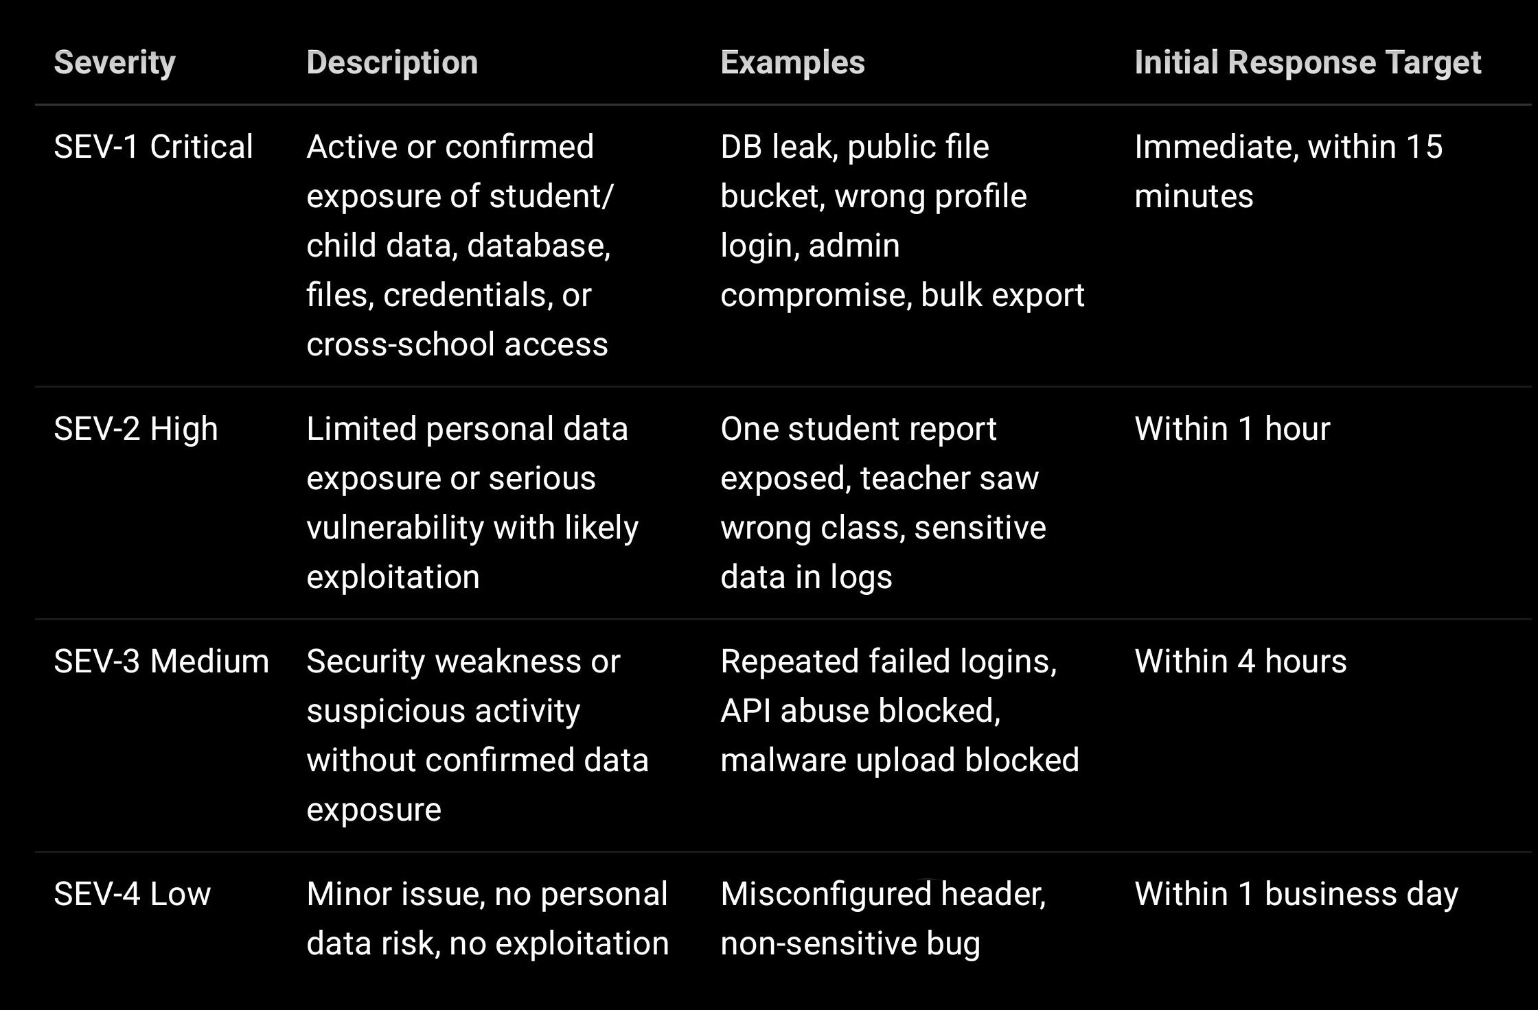

Automatic SEV-1 Conditions

Immediately classify as SEV-1 if any of the following occurs:

Student or parent data exposed publicly
Any child data accessed by an unauthorised user
Cross-school data access confirmed
MongoDB/database credentials leaked
Production database exposed
Admin/principal account compromised
Private file bucket made public
Plain passwords, JWTs, OTPs, or refresh tokens exposed
Bulk export downloaded by unauthorised user
AI/counselling report exposed to wrong user
Malware reached internal storage or admin workflow

---

5. Breach Response Roles

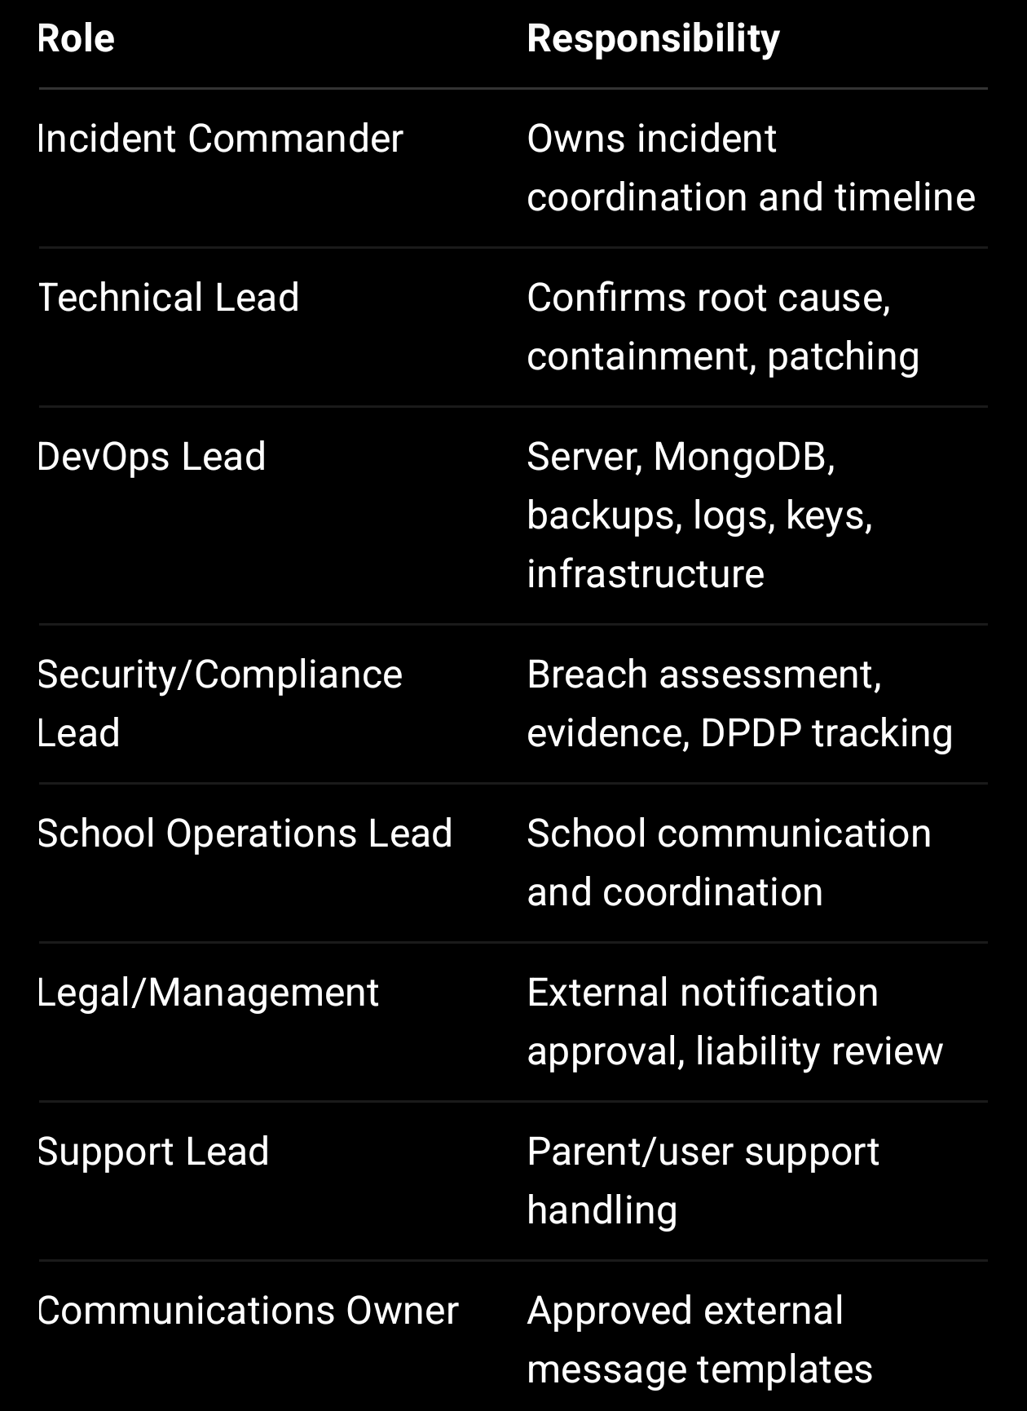

Emergency Contact Matrix

Function Contact

Security security@sproutsong.com
Privacy privacy@sproutsong.com
Support support@sproutsong.com
Management To be added
Legal To be added
DevOps To be added
School Ops To be added

---

6. Incident Response Timeline

0–15 Minutes: Detect and Escalate

Actions:

Log incident in incident register
Assign severity
Assign incident commander
Start incident timeline
Preserve initial evidence
Notify technical/security leads
If active exposure exists, contain immediately

For SEV-1, do not wait for full investigation before containment.

---

15–60 Minutes: Initial Containment

Actions may include:

Disable affected API
Revoke tokens
Increment token version
Block public file access
Disable affected user/admin account
Rotate leaked credentials
Restrict MongoDB/network access
Disable export/download feature
Disable affected AI/report/document module
Patch emergency access-control failure
Block suspicious IPs
Pause affected background jobs

Your internal breach readiness checklist recommends containment steps such as disabling the affected API, revoking tokens, changing credentials, blocking public access, patching vulnerabilities, and stopping further exposure.

---

1–4 Hours: Assessment and Evidence

Determine:

What happened?
Which module was affected?
Which school(s) were affected?
Which users were affected?
Was children’s data involved?
What data fields were exposed?
Was data viewed only, downloaded, exported, altered, or deleted?
Was the incident internal or external?
Was there malicious activity?
Is the issue still active?
Is any third-party processor involved?

The internal breach plan specifically requires checking what data was exposed, how many users were affected, whether children were affected, whether data was downloaded, whether the issue was internal/external, and whether malicious activity occurred.

---

4–24 Hours: Internal Decision and School Notification

For confirmed or likely personal data breach:

Prepare incident summary
Notify management/legal/compliance
Notify affected school/institution contact
Share facts, not speculation
Agree parent/user communication plan
Continue containment and patching
Start root cause analysis

Recommended school notification target:

Notify affected school within 24 hours of confirmation or reasonable suspicion of a material student/school data breach.

---

24–72 Hours: External Notification and Reporting

Depending on legal advice, contract, DPDP obligations, school DPA terms, and severity, prepare notification to:

Affected school(s)
Affected parent(s)/guardian(s)
Affected teacher(s)/mentor(s)
Affected student(s), where appropriate and child-sensitive
Regulatory authority / Data Protection Board, where legally required
Third-party provider, if involved
Cybercrime/hosting provider, if malicious activity is confirmed

Recommended internal target:

Complete breach assessment and notification decision within 72 hours.

Your internal materials state that DPDP includes personal data breach handling and notification obligations, and that breach risk is especially serious for children’s data because EdTech and schools have a higher duty of care.

---

3–7 Days: Root Cause Fix and Validation

Actions:

Patch code/configuration
Add missing validation
Add missing access checks
Update middleware
Review audit logs
Retest affected endpoint/module
Run regression tests
Re-scan security where applicable
Confirm no continued exposure
Prepare formal incident report
Update policies/SOP if required

The breach readiness plan states that after fixing, the team should add missing validation, improve access checks, update SOP, train team, record the incident, and prevent repeat issues.

---

7–30 Days: Post-Incident Review

Actions:

Final post-mortem
Management review
School closure report if required
Parent/user follow-up if required
Security control improvement
Training
Evidence archiving
Incident closure approval

---

7. Incident Response Lifecycle

Step 1: Identify

Sources of detection:

Audit logs
Application logs
API error logs
User reports
School reports
Parent complaints
Security scans
ZAP/Burp findings
Monitoring alerts
Database alerts
Cloud storage alerts
Unusual traffic
Failed access attempts
File scan alerts

Events that should be logged include login success/failure, password reset request, student report viewed, document downloaded, admin role change, bulk export, failed access attempts, and consent submitted/withdrawn.

---

Step 2: Triage

Classify:

Incident type
Severity
Affected module
Affected data
Affected users/schools
Current exposure status
Business impact
Child data impact
Legal/compliance impact

Triage questions:

Is student/child data involved?
Is data publicly exposed?
Is cross-school access involved?
Are credentials/tokens involved?
Can the incident continue right now?
Was data downloaded/exported?
Is the attacker still active?
Is a third-party provider involved?

---

Step 3: Contain

Containment differs by incident type.

Wrong User / IDOR / Cross-School Access

Immediate actions:

Disable affected endpoint
Patch schoolId/object-level query
Revoke sessions for affected users
Review access logs
Add test case
Deploy hotfix

Example secure rule:

const record = await Student.findOne({
_id: req.params.id,
schoolId: req.user.schoolId,
isDeleted: { $ne: true }
});

The backend API guide requires authentication, role-based permission checks, school/tenant ownership checks, object-level IDOR checks, input validation, secure logging, no secrets in responses, ObjectId validation, HTTPS, and restricted CORS for endpoints.

Token / Session Compromise

Immediate actions:

Increment tokenVersion
Revoke refresh tokens
Force password reset
Enable MFA for admin roles
Review login logs
Rotate JWT secret if required

await User.updateMany(
{ schoolId: affectedSchoolId },
{ $inc: { tokenVersion: 1 } }
);

Database Leak

Immediate actions:

Block DB network access
Rotate DB credentials
Disable leaked users
Check MongoDB logs
Review backup access
Assess exposed collections
Restore if tampered
Enable/verify auth and firewall

MongoDB guidance requires strong credentials stored only in environment variables, separate app/admin/backup users, credential rotation, strict Mongoose settings, and immediate rotation/audit if credentials are committed.

Public File Bucket / Document Exposure

Immediate actions:

Disable public-read ACL
Rotate signed URL keys if required
Identify exposed files
Remove public URLs
Check access logs
Notify affected school/users
Implement private bucket + signed URLs

File security guidance requires private bucket storage, signed URLs, access control before download, UUID naming, and never returning raw keys/public file paths to the client.

Malware Upload

Immediate actions:

Quarantine file
Disable download
Scan related storage
Alert security team
Check if accessed by admin/counsellor
Delete infected object
Patch upload validation/scanning

The file upload guide recommends ClamAV or cloud-native malware scanning and states that infected objects should be deleted, the incident recorded, and the security team alerted.

Sensitive Data in Logs

Immediate actions:

Restrict log access
Remove/redact affected logs where possible
Rotate exposed tokens/passwords
Patch logger redaction
Disable debug/trace in production
Review log retention

The logging guide warns that PII in logs, tokens in logs, passwords in logs, stack traces, Aadhaar, and cross-school data in logs can become breach vectors.

---

Step 4: Preserve Evidence

Preserve:

Request ID
User ID
Role
School ID
IP address
User agent
Timestamp
Endpoint pattern
Audit log
Server logs
DB logs
File access logs
Relevant screenshots
Affected record IDs
Containment actions
Code/config diff
Notification timeline

Do not preserve evidence by copying raw PII into chat/email/docs unnecessarily.

The logging guide recommends structured logs with requestId, userId, schoolId, role, method, route pattern, status, duration, and timestamp, while avoiding emails, names, raw tokens, full request bodies, and actual parameter values where possible.

---

Step 5: Assess Impact

Use this impact matrix:

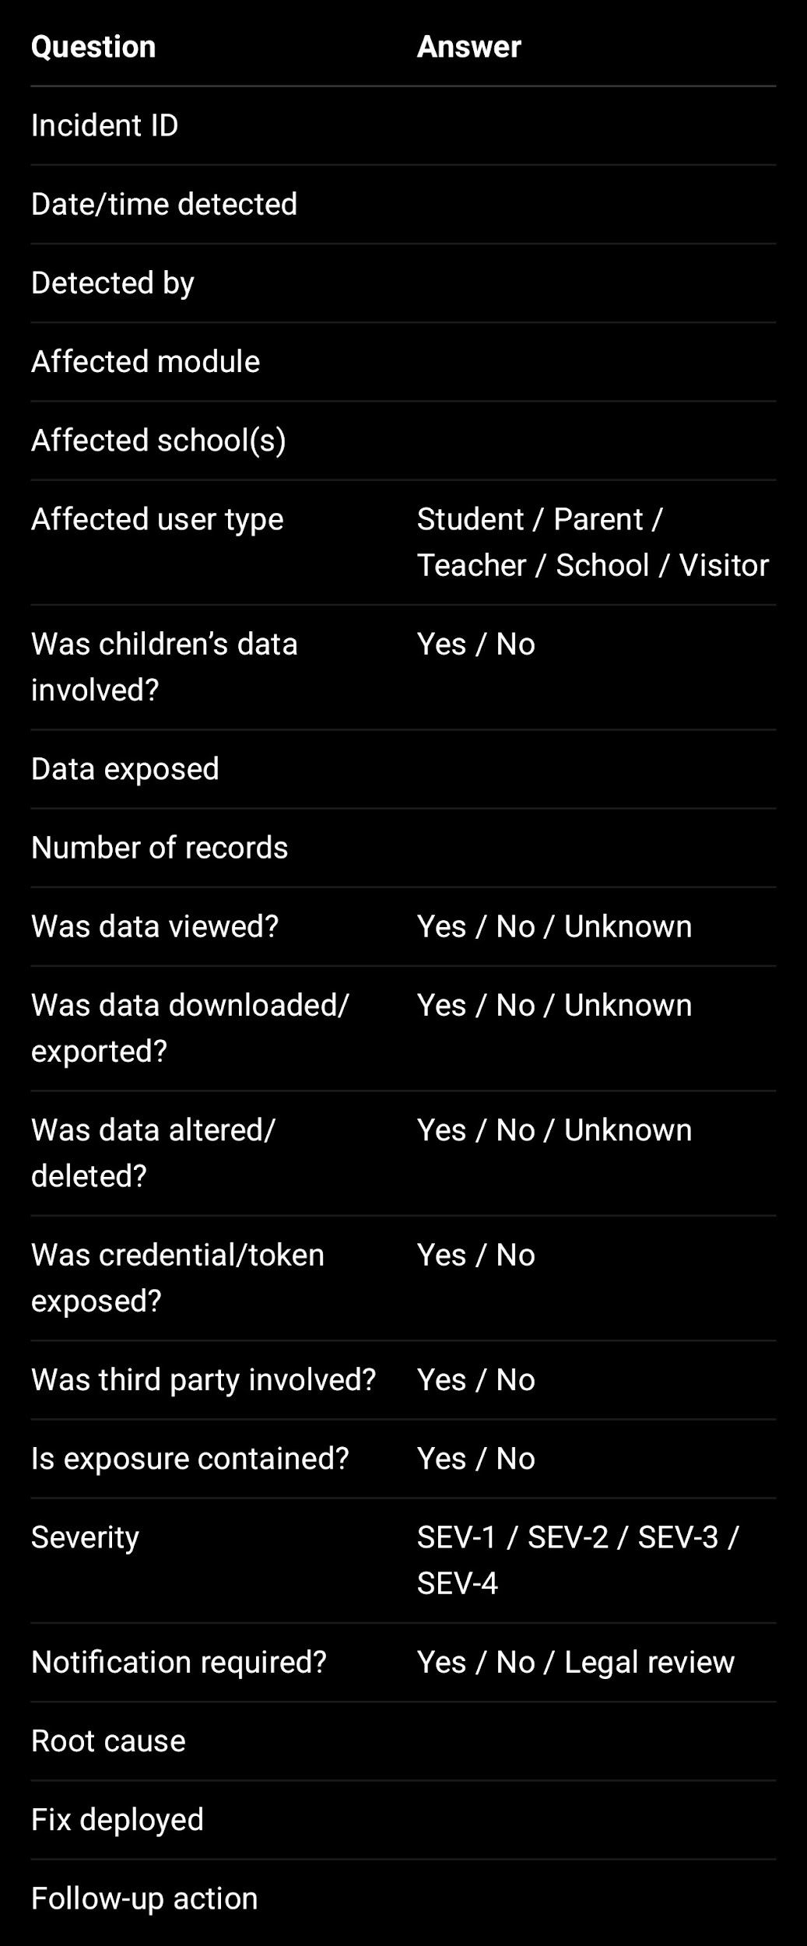

---

Step 6: Notify

Notification must be approved by Legal/Management/Compliance unless emergency school notification is needed to prevent further harm.

Who to notify

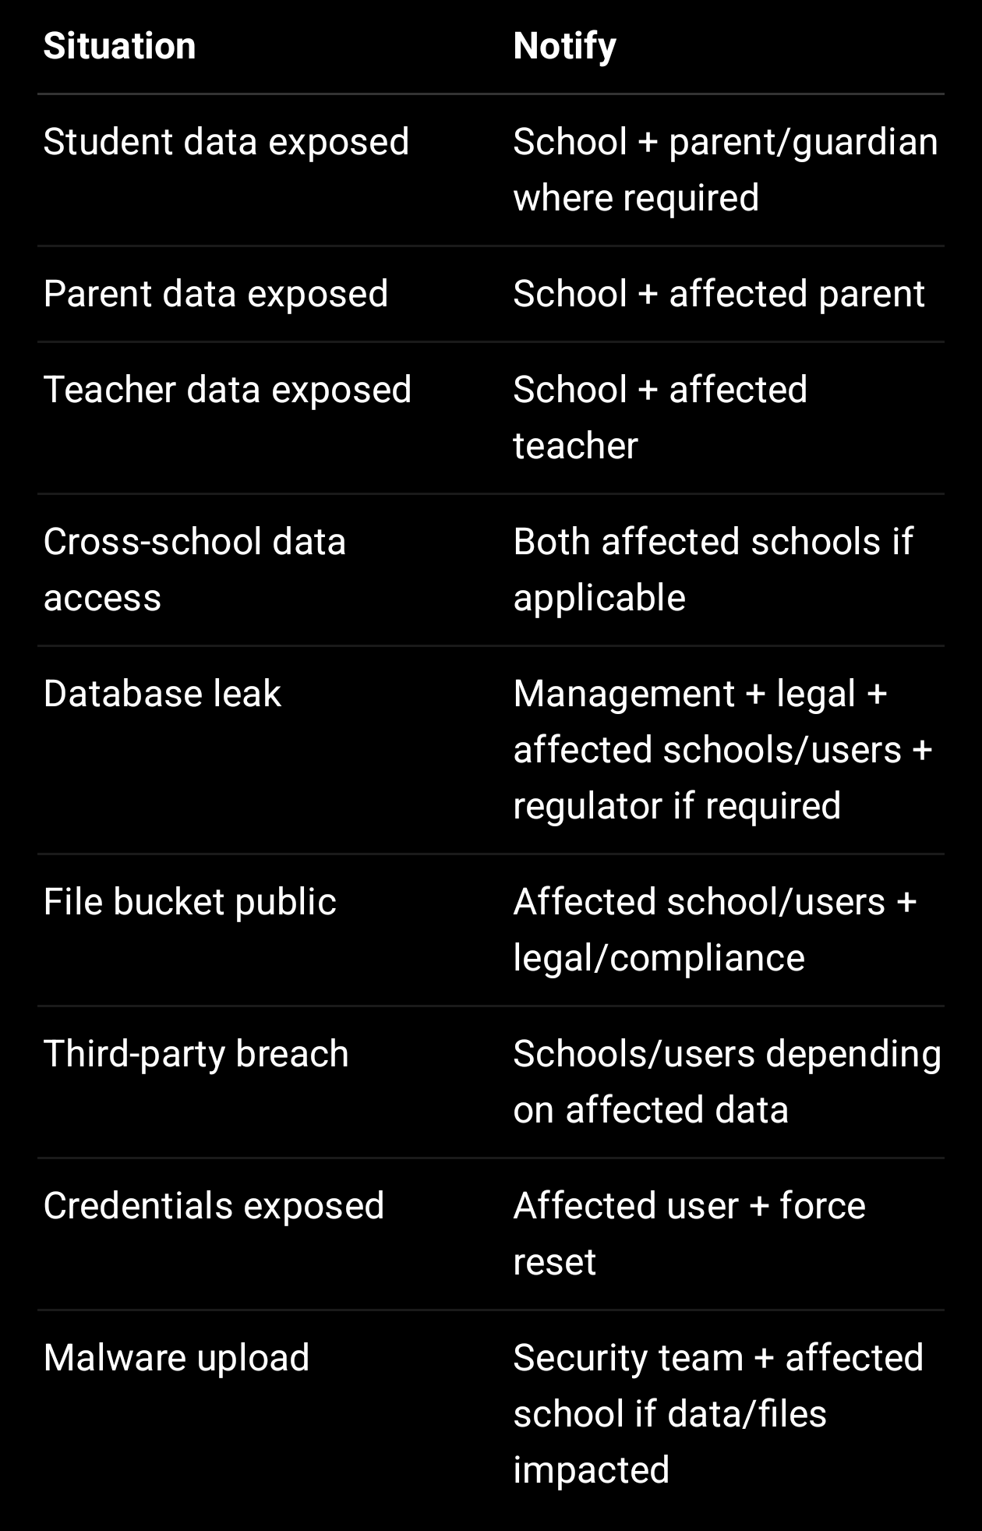

---

8. Notification Timelines

Internal Escalation

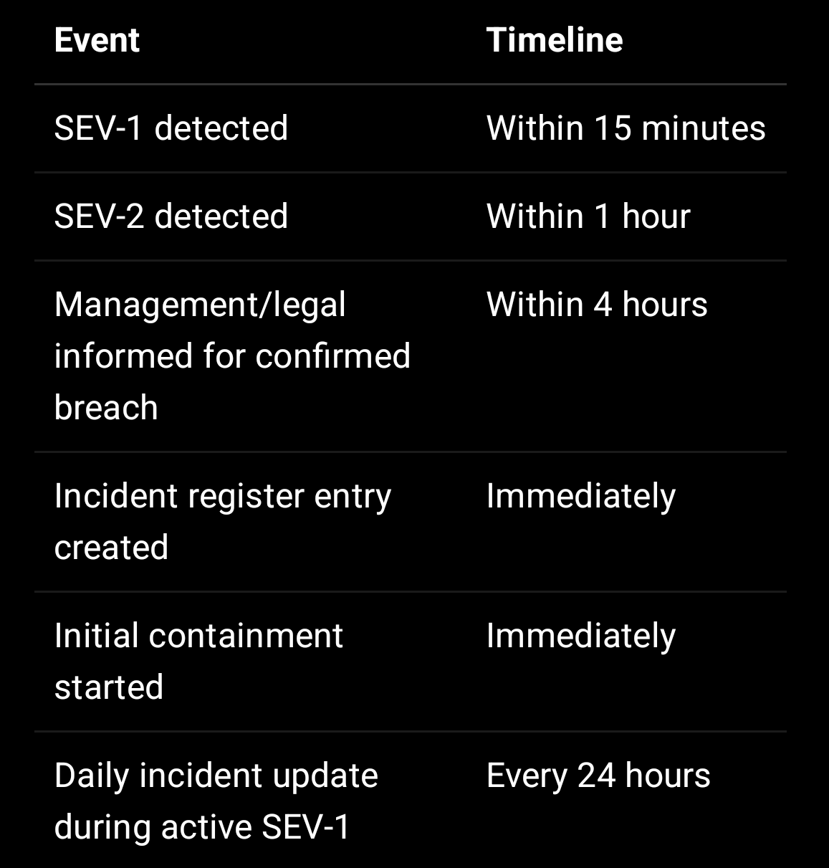

School Notification

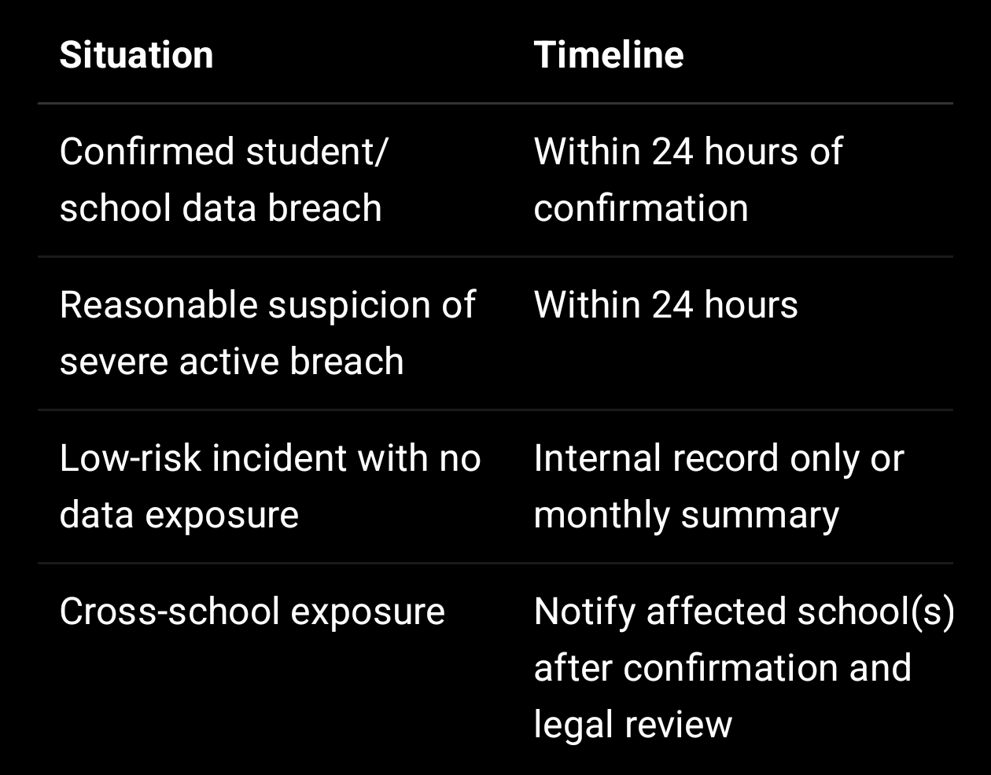

Parent/User Notification

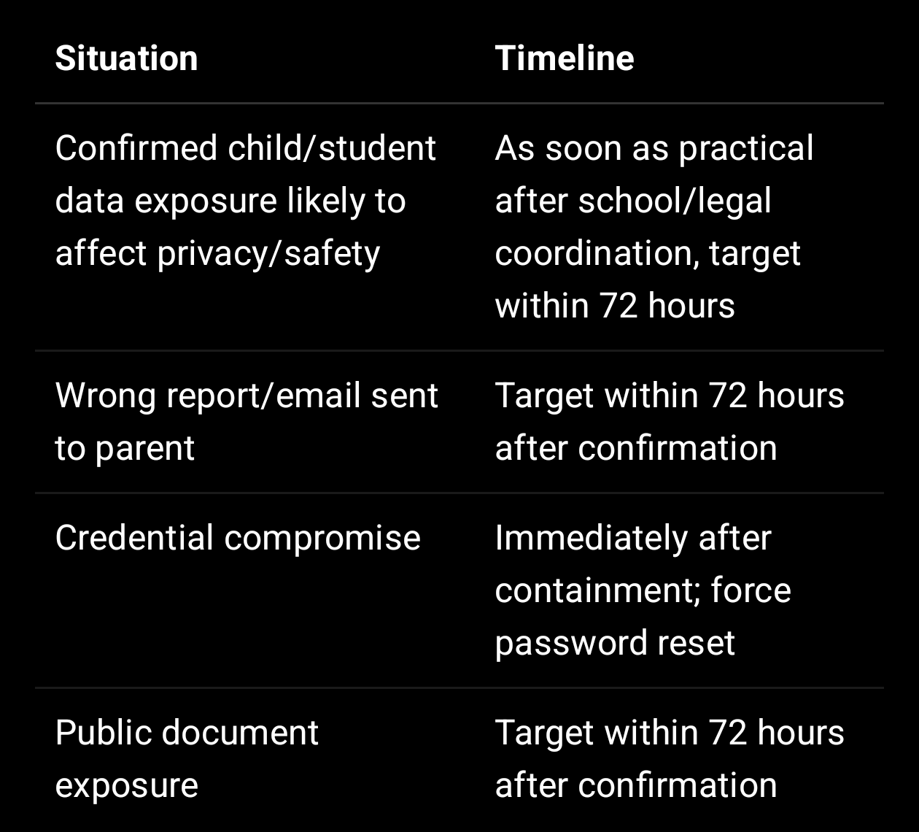

Regulatory / Legal Reporting

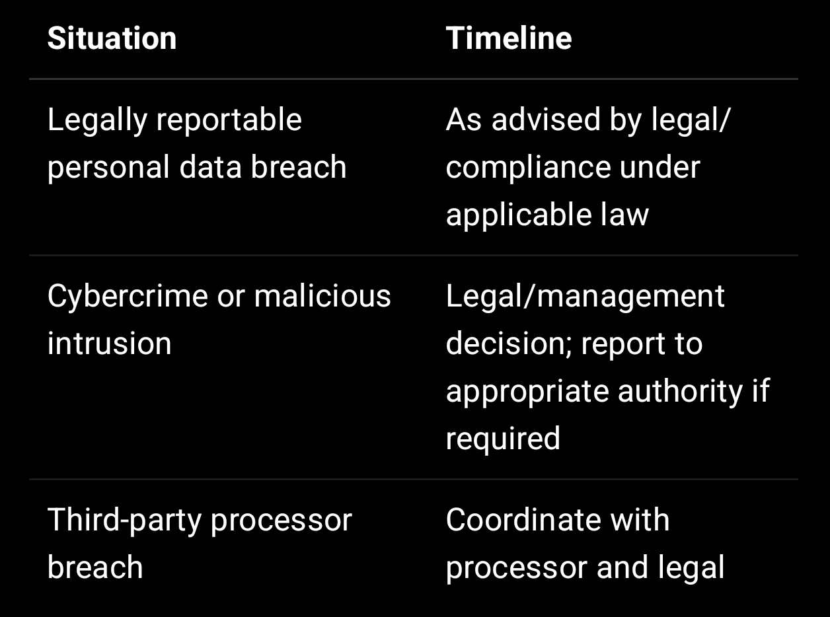

Internal operating target: complete impact assessment and notification decision within 72 hours for confirmed personal data breaches.

---

9. Communication Rules

Do

Share verified facts
Avoid speculation
State what happened
State what data may be affected
State what was done to contain it
State what user/school should do
Give contact email
Provide next update timeline

Do Not

Blame individuals publicly
Share technical exploit details unnecessarily
Expose another school/user’s data in notification
Send raw logs or sensitive screenshots
Make unsupported claims
Promise “no risk” unless verified
Disclose attacker details unless confirmed

---

10. Notification Templates

10.1 Internal SEV-1 Alert

Subject: SEV-1 Security Incident — Immediate Action Required

Incident ID:
Detected at:
Detected by:
Affected module:
Affected school/user type:
Suspected data involved:
Is child/student data involved:
Current exposure active: Yes/No/Unknown
Containment started:
Incident Commander:
Technical Lead:
Next update time:

Immediate actions required:
1.
2.
3.

---

10.2 School Notification Template

Subject: Security Incident Notification — [School Name]

Dear [School Contact Name],

We are notifying you of a suspected/confirmed security incident involving SproutSong / SproutMentors services used by your school.

Incident summary:
[Brief factual summary]

Date/time identified:
Affected module:
Data potentially affected:
Estimated number of affected records/users:
Whether student/children’s data was involved:
Whether data was viewed/downloaded/exported:
Current containment status:

Actions already taken:
1.
2.
3.

Recommended school action:
1.
2.

Next update:
We will provide the next update by [date/time] or sooner if material information becomes available.

Contact:
security@sproutsong.com
privacy@sproutsong.com

Regards,
SproutSong Security & Compliance Team

---

10.3 Parent/User Notification Template

Subject: Important Notice Regarding Your / Your Child’s Data

Dear [Parent/User Name],

We are writing to inform you of a security incident involving SproutSong / SproutMentors.

What happened:
[Brief plain-language explanation]

Information involved:
[Data categories, not excessive details]

What we have done:
1. Contained the issue
2. Secured the affected system
3. Reviewed access logs
4. Applied corrective action
5. Started additional monitoring

What you should do:
[Password reset / review account / contact school / no action required]

What this means:
At this stage, [explain known risk carefully].

Contact:
For questions, please contact privacy@sproutsong.com or support@sproutsong.com.

Regards,
SproutSong / SproutMentors Team

---

10.4 Credential Compromise Notice

Subject: Password Reset Required for Your SproutSong Account

Dear User,

We identified a security issue that may affect account credentials or session access.

As a precaution, we have signed out affected sessions and require you to reset your password.

Please reset your password using the secure link sent separately.

We recommend:
1. Do not share your password or OTP.
2. Use a strong password.
3. Contact support@sproutsong.com if you notice suspicious activity.

Regards,
SproutSong Security Team

—

11. Technical Incident Register

Create security_incidents collection.

const SecurityIncidentSchema = new mongoose.Schema({
incidentId: {
type: String,
unique: true,
index: true
},

severity: {
type: String,
enum: ["SEV_1", "SEV_2", "SEV_3", "SEV_4"],
required: true,
index: true
},

status: {
type: String,
enum: [
"OPEN",
"TRIAGED",
"CONTAINED",
"ASSESSING",
"NOTIFICATION_PENDING",
"NOTIFIED",
"RESOLVED",
"CLOSED"
],
default: "OPEN",
index: true
},

incidentType: {
type: String,
enum: [
"WRONG_USER_ACCESS",
"IDOR",
"CROSS_SCHOOL_ACCESS",
"DATABASE_LEAK",
"FILE_EXPOSURE",
"LOG_PII_EXPOSURE",
"CREDENTIAL_COMPROMISE",
"MALWARE_UPLOAD",
"EMAIL_MISDELIVERY",
"AI_REPORT_EXPOSURE",
"BULK_EXPORT",
"THIRD_PARTY_BREACH",
"OTHER"
],
required: true
},

detectedAt: {
type: Date,
required: true,
index: true
},

detectedBy: String,

affectedModules: [String],

affectedSchoolIds: [{
type: mongoose.Schema.Types.ObjectId,
ref: "School"
}],

affectedUserTypes: [String],

affectedRecordCount: Number,

childrenDataInvolved: {
type: Boolean,
default: false,
index: true
},

dataCategories: [String],

dataViewed: {
type: String,
enum: ["YES", "NO", "UNKNOWN"],
default: "UNKNOWN"
},

dataDownloaded: {
type: String,
enum: ["YES", "NO", "UNKNOWN"],
default: "UNKNOWN"
},

dataAlteredOrDeleted: {
type: String,
enum: ["YES", "NO", "UNKNOWN"],
default: "UNKNOWN"
},

maliciousActivity: {
type: String,
enum: ["YES", "NO", "UNKNOWN"],
default: "UNKNOWN"
},

rootCause: String,

containmentActions: [{
action: String,
performedBy: mongoose.Schema.Types.ObjectId,
performedAt: Date,
notes: String
}],

notification: {
schoolNotified: Boolean,
schoolNotifiedAt: Date,
parentsNotified: Boolean,
parentsNotifiedAt: Date,
regulatorNotified: Boolean,
regulatorNotifiedAt: Date,
notificationDecision: String,
approvedBy: mongoose.Schema.Types.ObjectId
},

evidenceRefs: [{
type: String,
refId: String,
description: String
}],

finalReportUrl: String,

closedAt: Date,
closedBy: mongoose.Schema.Types.ObjectId
}, {
timestamps: true
});

SecurityIncidentSchema.index({ severity: 1, status: 1, detectedAt: -1 });
SecurityIncidentSchema.index({ childrenDataInvolved: 1, detectedAt: -1 });

—

12. Audit Log Requirements During Incident

For every incident, preserve and review:

401/403 access denials
Login success/failure
Password reset events
Role/permission changes
Student report views
Document downloads
Bulk exports
AI report generation/approval
Consent changes
File upload/download events
DB admin access
Nginx/API logs
Cloud storage access logs

The secure logging guide states that logs should answer what happened, who triggered it, where, and when, using requestId, userId, schoolId, role, method, route pattern, status, duration, and timestamp.

Never log or include in incident reports:

Passwords
OTP
JWT / refresh token
Plain email/phone
Full Aadhaar
Student name where ID is sufficient
Parent name/address
DOB
Full request/response bodies
Counselling notes
Bank/card numbers
Production stack traces
MongoDB query objects

The logging guide provides this explicit “never log” blacklist and recommends alternatives such as ObjectId, HMAC/masked values, route patterns, and status codes.

—

13. Incident-Specific Playbooks

13.1 Wrong User Profile / IDOR

Symptoms:

User sees another student/parent profile
Report URL can be changed to access another record
Teacher sees non-assigned student data

Contain:

Disable endpoint or feature
Patch query with schoolId and ownership check
Revoke sessions for affected role
Review access logs
Notify school if personal data was exposed

Fix:

Add scopeToSchool
Add scopeToSelf
Add ObjectId validation
Add regression test

The backend guide requires authenticate → authorize → scopeToSchool → scopeToSelf chain on protected routes.

13.2 Database Leak

Symptoms:

MongoDB accessible from internet
Credentials leaked
Unknown DB login
Collections exported
Backup exposed

Contain:

Block port 27017
Rotate DB credentials
Disable compromised users
Check DB audit logs
Rotate app secrets
Review backups
Confirm MongoDB bind IP/private VPC

MongoDB guidance recommends localhost/private VPC binding, enabled authorization, separate app/admin/backup users, and strong credentials stored in environment variables only.

13.3 File Exposure

Symptoms:

Public file URL works without login
Bucket is public
Signed URL never expires
Student marksheet visible publicly

Contain:

Remove public ACL
Disable exposed URLs
Rotate signing keys if needed
Identify accessed files
Patch download route
Notify affected school/users

File upload guidance requires private storage, access control before download, signed URLs with expiry, and no raw key returned to clients.

13.4 Sensitive Logs

Symptoms:

Logs contain passwords, tokens, student names, parent phones, Aadhaar, counselling notes, full request body.

Contain:

Restrict log access
Purge/redact logs where possible
Rotate exposed secrets/tokens
Patch redaction config
Disable debug/trace in production
Review log retention

The secure logging guide says production must run at INFO level minimum, DEBUG/TRACE must be disabled in production, and Pino redaction should censor sensitive fields before logs are written.

13.5 Email Sent to Wrong Recipient

Contain:

Contact wrong recipient requesting deletion
Disable automatic email rule if needed
Check email template/recipient logic
Identify exposed data
Notify school and affected user if required
Patch recipient validation

Prevent:

Before sending reports, verify parent-child mapping and schoolId
Avoid attaching sensitive reports if secure portal link can be used
Use expiring signed report links instead of attachments

13.6 AI Report Exposure

Contain:

Disable AI report visibility
Revoke report links
Identify who viewed it
Check whether human review was bypassed
Notify school if student data exposed
Patch visibility logic

Prevent:

AI reports visible to student/parent only if:

humanReviewed = true
visibleToStudent / visibleToParent = true
same schoolId
linked parent/student access confirmed

The internal AI checklist requires minimising student data, removing identifiers where possible, avoiding sensitive prompt logs, reviewing AI output before final use, avoiding harmful labels, and requiring consent.

—

14. Containment Code Examples

Force Logout for Affected School

await User.updateMany(
{ schoolId: affectedSchoolId },
{ $inc: { tokenVersion: 1 } }
);

Disable Affected User

await User.updateOne(
{ _id: affectedUserId },
{
$set: {
status: "SUSPENDED",
suspendedAt: new Date(),
suspensionReason: "Security incident containment"
}
}
);

Block Feature Temporarily

if (process.env.DISABLE_REPORT_DOWNLOADS === "true") {
return res.status(503).json({
code: "FEATURE_TEMPORARILY_DISABLED",
message: "This feature is temporarily unavailable."
});
}

Emergency Audit Log

await AuditLog.create({
requestId: req.requestId,
actorId: req.user?._id,
actorRole: req.user?.role || "SYSTEM",
schoolId: req.user?.schoolId,
module: "security",
action: "INCIDENT_CONTAINMENT",
result: "allowed",
recordType: "SecurityIncident",
recordId: incident._id,
ipAddress: req.ip,
userAgent: req.headers["user-agent"],
metadata: {
incidentId: incident.incidentId,
actionTaken: "TOKEN_VERSION_INCREMENTED"
},
createdAt: new Date()
});

—

15. External Reporting and DPDP Handling

This policy should be legally reviewed before publication/signing. For operational purposes:

SproutSong should maintain a process to notify affected schools/users and, where legally required, the appropriate authority. The internal materials already note that DPDP includes obligations around personal data breach handling and notifications.

Internal Rule

For every confirmed personal data breach:

- Complete incident assessment.
- Determine if children’s data is involved.
- Determine if external notification is required.
- Obtain legal/management approval.
- Notify affected school(s).
- Notify affected parent/user where applicable.
- Keep proof of notification.
- Store final incident report.

—

16. Incident Closure Criteria

An incident can be closed only when:

Exposure is contained
Root cause is identified
Patch is deployed
Regression tests passed
Affected data/users assessed
Notification decision documented
Required notifications completed
Audit evidence archived
Incident report completed
Preventive actions assigned
Management/compliance approves closure

—

17. Post-Incident Report Template

Incident ID:
Severity:
Status:
Detected at:
Closed at:
Incident commander:
Affected module:
Affected school(s):
Affected user type:
Children’s data involved:
Data categories affected:
Number of records affected:
Was data viewed:
Was data downloaded:
Was data altered/deleted:
Root cause:
Timeline:
Containment actions:
Notifications sent:
Legal/compliance decision:
Fix deployed:
Tests added:
Monitoring added:
Policy/SOP updates:
Training required:
Final risk rating:
Approved by:

—

18. Training and Testing

SproutSong should run breach response testing:

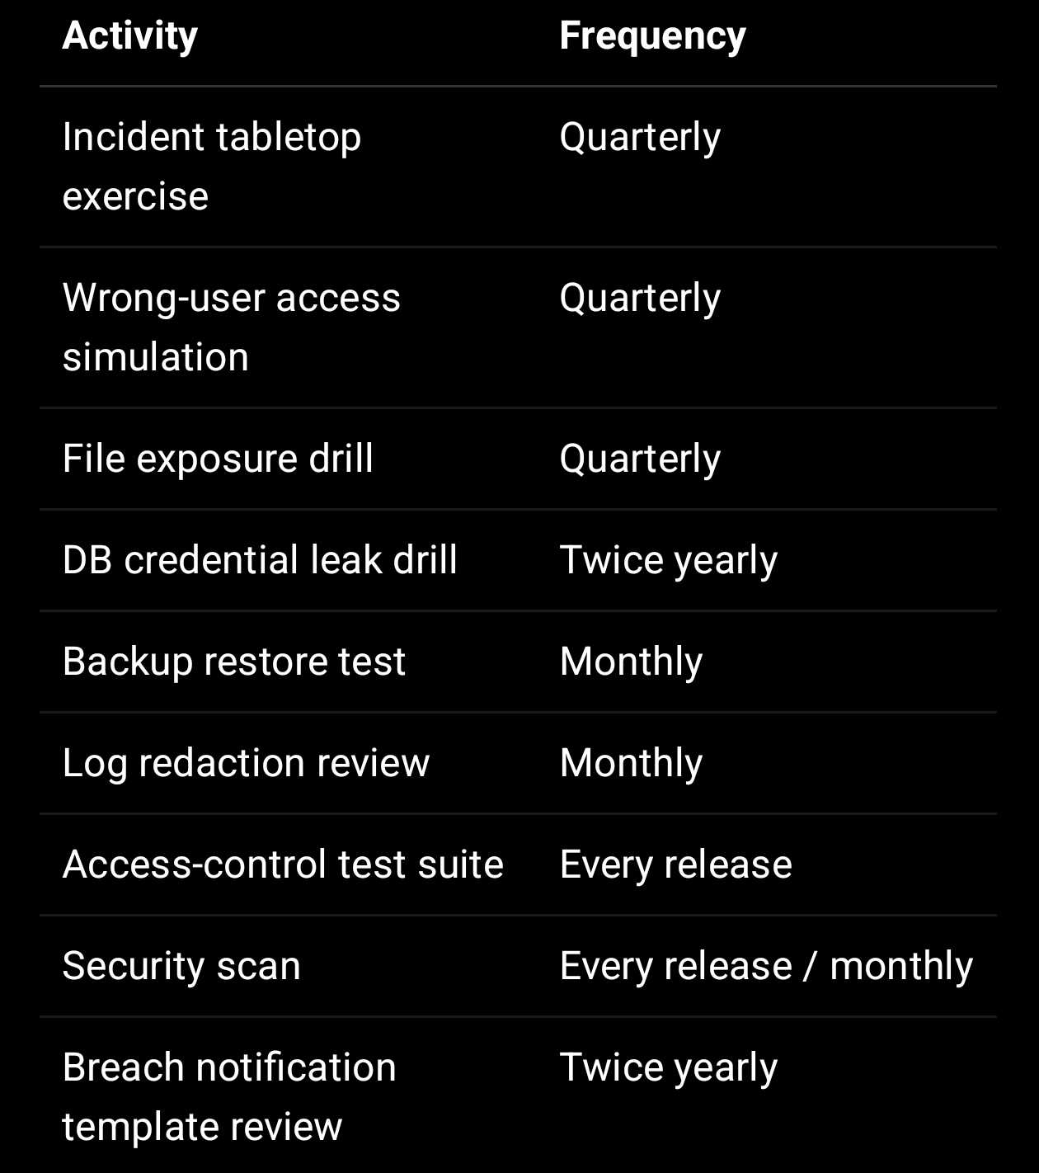

The weekly teamship plan already includes monitoring review, sensitive logging review, breach response SOP preparation, final recommendations, and security monitoring checklist.

—

19. Website-Facing Summary

Use this as the public-facing version:

SproutSong / SproutMentors takes security incidents and personal data breaches seriously.

If we identify a confirmed or suspected breach involving personal data, especially children’s/student data, we will take immediate steps to contain the issue, protect affected users, investigate the cause, and notify affected schools, users, parents/guardians, and authorities where required.

We maintain internal incident response procedures, audit logs, security monitoring, access controls, and breach documentation to reduce risk and improve our systems.

Security or privacy concerns can be reported to security@sproutsong.com or privacy@sproutsong.com.

—

20. Final Implementation Checklist

Before approving this policy:

- Assign incident commander and backup.
- Add security@sproutsong.com mailbox or ticket queue.
- Create security_incidents collection.
- Add SEV-1/SEV-2 alerting.
- Add audit log review process.
- Add force logout/token revocation script.
- Add endpoint kill-switch config.
- Add public file exposure checklist.
- Add MongoDB credential rotation SOP.
- Add parent/school notification templates.
- Define legal/regulatory notification approval process.
- Add incident evidence storage location.
- Add incident post-mortem template.
- Train support, engineering, school ops, and management.
- Test one incident drill before launch.
- Review and update every 6 months.

—

Final Internal Note

This policy should be linked with:

Privacy Policy
Terms & Conditions
Child Data Protection Policy
Consent Policy
Data Retention Policy
School Data Processing Agreement
Cookie Policy
AI Usage Disclaimer
Secure Logging & PII Masking Guide
Backend API Security Guide
MongoDB Security Guide
File Upload Security Guide

Your internal readiness guide explicitly lists Breach Response Policy as a recommended public/compliance document for DPDP readiness.

